

School of Pure and Applied Sciences

PROJECT PROPOSAL

PROJECT TITLE: ONLINE JOBS PORTAL

JOSEPH GITAU JUMA

CT101/G/6269/19

A RESEARCH PROPOSAL SUBMITTED IN PARTIAL FULFILLMENT FOR THE DEGREE OF BACHELOR OF SCIENCE IN COMPUTER SCIENCE AT KIRINYAGA UNIVERSITY.

NOVEMBER, 2022

DECLARATION

I hereby declare that this project is my original work and has not been presented for a degree or any other award in any other university.

Sign………………………………. Date………………………………….

I confirm that the work reported in this project was carried out by the candidate under my supervision.

Sign………………………………. Date………………………………….

DEDICATION

I would like to dedicate this research paper to my parents and the university for their unfailing support throughout this project implementation.

ACKNOWLEDGEMENT

I would like to thank the almighty God for his grace that will enable the completeness of this research paper as well as my lecturers and supervisor for their continued support in making the making of this research project a reality.

ABSTRACT

The project will aim to develop an online portal where employers can post job opportunities and interested and qualified persons can apply for the job opportunities posted. The system will be an online job application portal unique to a certain area as the jobs posted will require physical presence. Users can sign up and create their profile either as an employer or an employee which will then require verification from the admin. The employee can then upload their cv which will contain the specific skills he/she can offer. The employer can choose employees based on his/her requirements and the employees’ capabilities and then decide to hire the employee. The employee can apply to job postings posted by different employers. Chapter one covers the objectives and functions of the proposed system. The objectives of the system are to develop a platform where job seekers can upload their CVs and employers can hire qualified applicants. The major limitation of the proposed system is that it is only accessible to users with access to smartphones and internet connectivity. Chapter two covers the review of already existing systems similar to the proposed online jobs portal system. This chapter also identifies the gaps within these systems and tries to solve some of them. Chapter three covers the software development methodology that will be used to develop the system. The methodology that will be used will be the agile methodology for its ease of use and flexibility. In Chapter 4, the system design is described in detail, including the requirements, process design, and database design of the system. Chapter 4 outlines the objectives, functional and non-functional requirements of the system. It provides a flowchart that visually represents the process design of the system and a description of the database design, including the tables and SQL columns that were defined to store the relevant information for job postings, user profiles, and job applications. The output design is also described, including the types of outputs that will be produced by the system, how they will be presented to the users, and the security features that will be implemented to protect the users’ information. The information presented in Chapter 4 serves as a blueprint for the development of the online jobs portal system, providing a clear understanding of the system's design and its various components. The successful implementation of this chapter will ensure that the online jobs portal system is efficient, user-friendly, and meets the needs of both employers and employees.

TABLE OF CONTENTS

Contents

[CHAPTER ONE: INTRODUCTION 1](#_Toc128061374)

[1.1 INTRODUCTION 1](#_Toc128061375)

[1.2 BACKGROUND OF THE STUDY 1](#_Toc128061376)

[1.3 CURRENT SYSTEM 2](#_Toc128061377)

[1.4 PROBLEM STATEMENT 3](#_Toc128061378)

[1.5 PROPOSED SYSTEM 4](#_Toc128061379)

[1.6 PURPOSE OF THE STUDY 5](#_Toc128061380)

[1.7 GENERAL OBJECTIVE 6](#_Toc128061381)

[1.8 SPECIFIC OBJECTIVES 6](#_Toc128061382)

[1.9 JUSTIFICATION 7](#_Toc128061383)

[1.10 SCOPE 8](#_Toc128061384)

[1.11 LIMITATIONS 8](#_Toc128061385)

[1.12 SIGNIFICANCE OF THE STUDY 8](#_Toc128061386)

[1.13 OPERATIONAL DEFINITIONS OF TERMS 9](#_Toc128061387)

[1.14 SUMMARY 9](#_Toc128061388)

[CHAPTER TWO: LITERATURE REVIEW 2 10](#_Toc128061389)

[INTRODUCTION 10](#_Toc128061390)

[RELATED LITERATURE REVIEW 10](#_Toc128061391)

[Indeed 10](#_Toc128061392)

[BrighterMonday 11](#_Toc128061393)

[Flexjobs 12](#_Toc128061394)

[2.2.4 Ajira 13](#_Toc128061395)

[Fuzu 14](#_Toc128061396)

[GAPS/LACUNAS 16](#_Toc128061397)

[CONTEXT DIAGRAM/CONCEPTUAL FRAMEWORK 16](#_Toc128061398)

[CHAPTER CONCLUSION 17](#_Toc128061399)

[CHAPTER THREE: SYSTEM RESEARCH METHODOLOGY 18](#_Toc128061400)

[3.1 INTRODUCTION 18](#_Toc128061401)

[3.2 DEVELOPMENT METHODOLOGY 18](#_Toc128061402)

[1. Requirement gathering and analysis 19](#_Toc128061403)

[3.3 JUSTIFICATION OF METHODOLOGY 22](#_Toc128061404)

[3.4 DATA COLLECTION 24](#_Toc128061405)

[3.5 DATA ANALYSIS 25](#_Toc128061406)

[3.6 CHAPTER CONCLUSION 27](#_Toc128061407)

[CHAPTER FOUR: SYSTEM DESIGN 28](#_Toc128061408)

[4.1 INTRODUCTION 28](#_Toc128061409)

[4.2 REQUIREMENTS 28](#_Toc128061410)

[4.3 CONTEXT LEVEL DIAGRAM 30](#_Toc128061411)

[4.4 INPUT DESIGN (USER INTERFACES) 32](#_Toc128061412)

[4.5 PROCESS DESIGN 35](#_Toc128061413)

[4.6 DATABASE DESIGN 37](#_Toc128061414)

[4.7 OUTPUT DESIGN 42](#_Toc128061415)

[4.8 CHAPTER CONCLUSION 42](#_Toc128061416)

[CHAPTER FIVE: SYSTEM TESTING AND IMPLEMENTATION 43](#_Toc128061417)

[5.1 INTRODUCTION 43](#_Toc128061418)

[5.2 UNIT TESTING 43](#_Toc128061419)

[5.3 INTEGRATION TESTING 47](#_Toc128061420)

[5.4 SYSTEM TESTING 47](#_Toc128061421)

[5.4 DATABASE TESTING 48](#_Toc128061422)

[5.5 IMPLEMENTATION OF REQUIREMENTS 48](#_Toc128061423)

[5.6 CODING TOOLS 48](#_Toc128061424)

[5.7 SYSTEM HOMEPAGE 49](#_Toc128061425)

[5.8 CHAPTER CONCLUSION 53](#_Toc128061426)

[CHAPTER SIX: CONCLUSIONS AND RECCOMMENDATIONS 55](#_Toc128061427)

[6.1 INTRODUCTION 55](#_Toc128061428)

[6.2 CONCLUSION 55](#_Toc128061429)

[6.3 RECCOMMENDATION 55](#_Toc128061430)

[6.4 FUTURE WORK 55](#_Toc128061431)

[REFERENCES 55](#_Toc128061432)

[APPENDICES 57](#_Toc128061433)

LIST OF TABLES

[Table 1: Budget 29](#_Toc119655297)

dfd

LIST OF FIGURES

[[Figure 2. 1 Indeed homepage 11](C:\\Users\\Axzyte\\Documents\\JOSEPH GITAU JUMA project proposal.docx" \l "_Toc128061258)](#_Toc128061446)

[[Figure 2. 2: Brighter Monday homepage 12](C:\\Users\\Axzyte\\Documents\\JOSEPH GITAU JUMA project proposal.docx" \l "_Toc128061258)](#_Toc128061447)

[[Figure 2. 3: Flexjobs system homepage 13](C:\\Users\\Axzyte\\Documents\\JOSEPH GITAU JUMA project proposal.docx" \l "_Toc128061258)](#_Toc128061448)

[[Figure 2. 4: Ajira system homepage 14](C:\\Users\\Axzyte\\Documents\\JOSEPH GITAU JUMA project proposal.docx" \l "_Toc128061258)](#_Toc128061450)

[[Figure 2. 5: Fuzu system homepage 15](C:\\Users\\Axzyte\\Documents\\JOSEPH GITAU JUMA project proposal.docx" \l "_Toc128061258)](#_Toc128061451)

[[Figure 2. 6: Conceptual Framework 16](C:\\Users\\Axzyte\\Documents\\JOSEPH GITAU JUMA project proposal.docx" \l "_Toc128061258)](#_Toc128061452)

[[Figure 3.3.2:1 Agile methodology 19](C:\\Users\\Axzyte\\Documents\\JOSEPH GITAU JUMA project proposal.docx" \l "_Toc128061258)](file:///C:\Users\Axzyte\Documents\JOSEPH%20GITAU%20JUMA%20project%20proposal.docx#_Toc128061453)

[[Figure 4.1 context level diagram 31](C:\\Users\\Axzyte\\Documents\\JOSEPH GITAU JUMA project proposal.docx" \l "_Toc128061258)](#_Toc128061454)

[[Figure 4.2: Registration page 33](C:\\Users\\Axzyte\\Documents\\JOSEPH GITAU JUMA project proposal.docx" \l "_Toc128061258)](#_Toc128061455)

[[Figure 4.3: Login form 34](C:\\Users\\Axzyte\\Documents\\JOSEPH GITAU JUMA project proposal.docx" \l "_Toc128061258)](#_Toc128061456)

[[Figure 4.4: Job posting 35](C:\\Users\\Axzyte\\Documents\\JOSEPH GITAU JUMA project proposal.docx" \l "_Toc128061258)](#_Toc128061457)

[[Figure 4.5: process design flowchart 37](C:\\Users\\Axzyte\\Documents\\JOSEPH GITAU JUMA project proposal.docx" \l "_Toc128061258)](#_Toc128061458)

[Figure 5. 1 online jobs portal homepage 52](#_Toc128062368)

[Figure 5. 2 online jobs portal registration page 52](#_Toc128062369)

[Figure 5. 3: online jobs portal browse jobs page 53](#_Toc128062370)

[Figure 5. 4: online jobs portal contact employer page 53](#_Toc128062371)

[Figure 5. 5: online jobs portal upload qualifications page 54](#_Toc128062372)

[Figure 5. 6: online jobs portal add job listings page 54](#_Toc128062373)

# CHAPTER ONE: INTRODUCTION

## INTRODUCTION

The aim of online jobs portal project is to develop an online search Portal for job applications from interested job seekers. The system project will be an online web application that can be accessed anywhere by people with proper authorization. The system will be used as an Online Jobs Portal for job seekers. Job Seekers will be able to log in and upload their resumes. Different Companies and organizations may also log in and access or search any information uploaded by Job seekers.

## 1.2 BACKGROUND OF THE STUDY

The main aim of the project is developing an online job portal where job details can be shared with job seekers. The portal is an online platform that can be accessed by anyone with a smartphone and internet connectivity. The system will be an online job portal where users will sign up, log in and find the right job match for their skills. This will intern solve the unemployment issues in society as now the job seekers will be able to know of the available job opportunities. The system will also ensure that the job seekers get the right job for their skills as they will have uploaded their CVs and have a wide range of jobs to choose from.

## 1.3 CURRENT SYSTEM

The current system in place involves the job seeker having to have previous experience with the employers or knowing someone who might help them secure the job position. This system creates a hindrance to a job seeker with good qualification stats but doesn’t know the employer or anyone to help him/her directly. To eliminate such issues the proposed system will provide an interface where anyone can apply and qualify for a job position as long as they have the required skills by the employer.

## PROBLEM STATEMENT

Finding a job opportunity has become increasingly difficult in the country, therefore,

leading to a high rate of unemployment. It is difficult to find a job opportunity because

one cannot find a means to communicate with the employer to ask for a job and the

information about the available job opportunities doesn’t get to the interested person. These issues necessitate a platform where employers and users can interact and share job

information.

## 1.5 PROPOSED SYSTEM

The proposed system is aimed at providing an interface where job seekers can find available posted jobs in the portal easily. The system is aimed at providing a non-biased platform where job seekers can find jobs that they best qualify for provided they are capable of fulfilling the job description. Job seekers have the freedom of choosing the jobs they always wanted if they are available and proving they are capable to do the job description as required by the employer.

## 1.6 PURPOSE OF THE STUDY

The main purpose of the system is to develop an online job portal where job seekers can find available jobs according to their skill level and apply for them.

## 1.7 GENERAL OBJECTIVE

To create an online jobs portal where job seekers and employers can interact and share job details.

## 1.8 SPECIFIC OBJECTIVES

The specific project objectives of the research are:

1. Developing a system that will allow employers to upload job details and advertise different job opportunities.
2. To create a platform where job applicants can upload their job qualifications.

3. To develop a module that will recommend the most qualified applicant to the

employers

4. To develop a platform that will automatically search for jobs that a given job applicant is qualified for and inform them.

## 1.9 JUSTIFICATION

The high rate of unemployment in the country has increasingly become a problem. Job seekers don’t have a way to get available job opportunities easily and hence the need for a platform easily accessible to get job information. The job portal will provide a platform where available job opportunities will be easily accessible to job seekers.

## 1.10 SCOPE

The scope of the project will involve explaining to what extent the proposed project will cover job seekers and employees. The system will mostly cover a small area as it is targeted at normal-class citizens. The employees will also be affected depending on the available job seekers.

## 1.11 LIMITATIONS

Some of the challenges that the online jobs portal will face are:

1. It will be difficult to measure the effectiveness of the online jobs portal since the usage data is not readily available.
2. Users without access to a smartphone won’t be able to access the online jobs portal as it requires access to a smartphone and internet connectivity.
3. The portal may attract fraudulent applicants as they can take advantage of the job posting information to perform fraud.

## 1.12 SIGNIFICANCE OF THE STUDY

1. The online jobs portal will allow an immediate response from involved parties, therefore, making the job get finished on time.
2. A bigger audience can be reached by the employer as the job posting will be made public to every user in the platform making it possible for the employer to choose the highest qualified job applicant.
3. The jobs portal platform will make the job listing easily accessible to everyone as they can access it from any location, they are in.

## 1.13 OPERATIONAL DEFINITIONS OF TERMS

Job seeker: A person who have some qualifications for a particular job and is looking for that job to be employed.

Stakeholder: Stakeholders are people or parties that will be affected by a project at any point in its life cycle, and their input can directly impact the outcome of the project.

Observations: A value of interest that a researcher measures or counts during a study or experiment.

## 1.14 SUMMARY

In summary, the proposed job portal system will help lower the unemployment rate in the country by providing a platform for job seekers to apply for available job positions. This will increase the standards of living in the country, therefore, promoting its development.

# CHAPTER TWO: LITERATURE REVIEW 2

## INTRODUCTION

The aim of this chapter is to review related literatures and identify existing gaps in the existing systems. This chapter will explore the existing online job portals and identify the gaps in the explored systems. The systems explored will provide a basis under which the proposed system will be developed by analyzing its weaknesses, strengths, and functionalities.

## RELATED LITERATURE REVIEW

The following systems will be analyzed as they already are online job portals.

### Indeed

Indeed, is a job site that strives to putting job seekers first by giving them access to search for jobs, post resumes, and research companies. Indeed, help connect job seekers to new job opportunities are they become available. Indeed, works by providing the valuable job search tools. Indeed allows its users to create an account, upload their resume and search from a vast selection of opportunities that fits the user-specific criteria.

The user creates an account on the indeed website and uploads their resume. The uploaded resume will be used by the user when he/she is applying for a job position. The user can then search for salaries by job title and location. The registered user can then verify employer offerings by looking at company reviews. The user of indeed can search for jobs and save the job listings that interest them for later review.

Some of the advantages of the Indeed system include, the user can easily search for relevant jobs by keywords, title, industry, and location plus the job filter available allows the user to narrow down results. Indeed, also allows the posting of different kinds of work including internship, freelance, and part-time jobs. Candidates in the Indeed system can upload their resumes for easy and quick job applications.

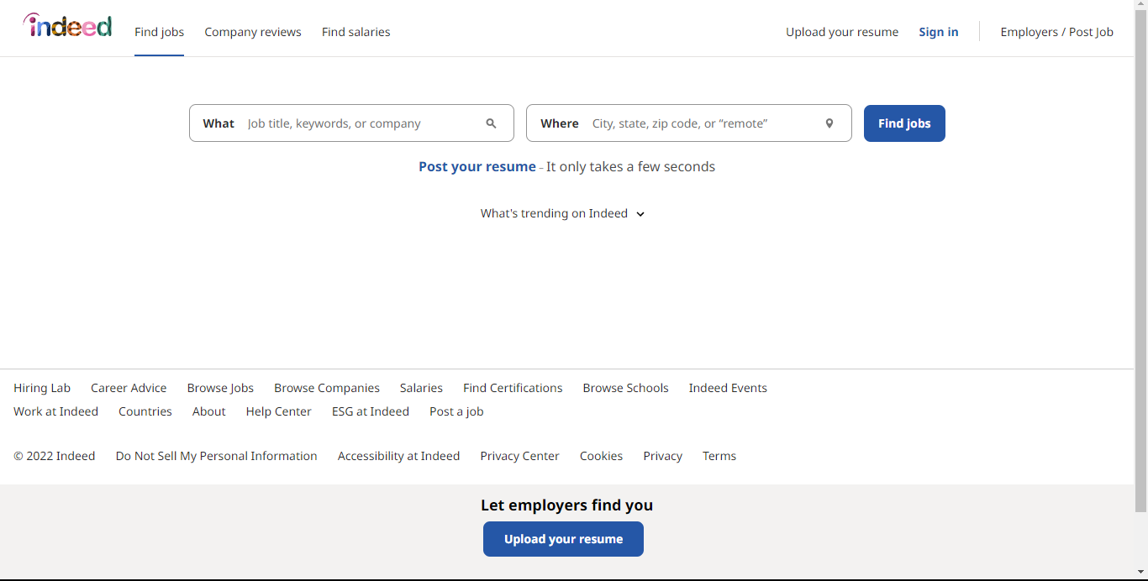

Figure 2. Indeed homepage

### BrighterMonday

BrighterMonday is an online platform that connects qualified professional job seekers to employers to help grow their businesses. BrighterMonday was established in 2006 with the aim of digitizing Human Resources and transforming productivity in Kenya. BrighterMonday uses both human-made solutions and automated solutions to match employers with the best candidates for the particular need so that they can hire the right fit faster.

For a job applicant to become part of BrighterMonday, the applicant has to sign up through the BrighterMonday website, enter their personal information and confirm the information. The information entered includes the applicant's name, email address, phone number, date of birth, gender, and the applicant’s current location. The applicant also has to provide their highest qualifications, current job, years of experience, and availability. The applicant can then upload their resume and have successfully created their account. The applicant can view the available job posting and act accordingly.

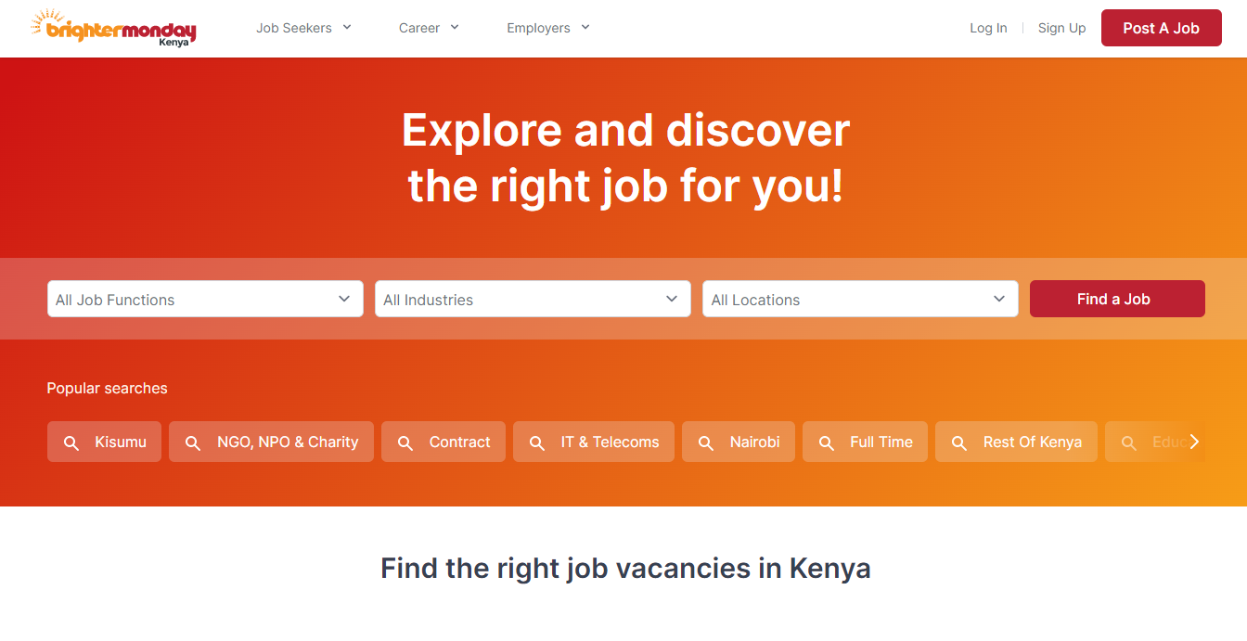

Figure 2. : Brighter Monday homepage

### Flexjobs

Flexjobs was created in year 2007 to provide a trusted, more efficient, friendly, and overall better way to find professional remote and flexible jobs world-wide. Flexjobs provides an opportunity where job applicants can register and browse the remote available jobs. The user signs up by filling in their details e.g., name, date of birth, gender, and current location, and then uploads a resume which is used for reference. The system helps the job applicant by connecting him/her with the appropriate job opportunities if they are available.

The benefits of flex jobs are; Flexjobs provide a platform where qualified job applicants can easily connect and get the job they qualify for. Flexjobs help connect job seekers to the available job opportunities and industries, therefore, making the job seeker have an easy time finding the job they qualify for.



Figure 2. : Flexjobs system homepage

### 2.2.4 Ajira

Ajira is a digital Kenyan government initiative that is driven by the ministry of ICT, innovations, and youth affairs that its aim is to empower young energetic people to get access to digital job opportunities. The program seeks to empower local companies and industries to create digital work. Access to digital work will build wealth and grow the middle class across the country and create a larger middle class that will create more opportunities for business and direct growth of GDP. The main objectives of Ajira are; to raise the profile of digital work; to promote a mentorship and collaborative learning approach to finding digital work; to provide Kenyans with access to digital work, and finally Promote Kenya as a destination for online workers.

The benefits of the Ajira system are: creating access to dignified work by helping to grow digitized local work, providing education and skills to the dynamic and always-changing online jobs, giving access to infrastructure such as innovation Hubs, Kazi connect centers and channels, and creating awareness by building trust and confidence.

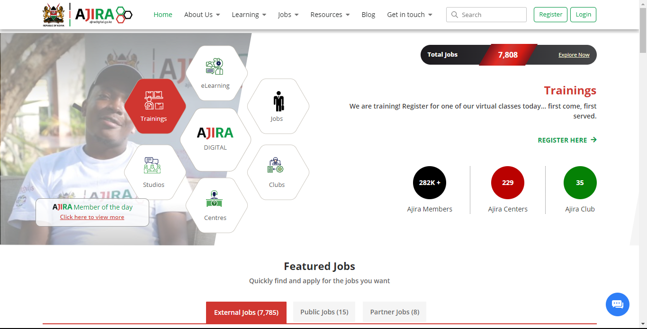

Figure 2. : Ajira system homepage

### Fuzu

Fuzu is a platform that helps job seekers find available jobs in their area of interest and apply for them. Fuzu allows anyone above 18 years of age and looking for a job to use their platform to find their dream job. A job applicant sign-up to the platform fills in their details which include name, year of birth, email address, gender, and current location, and uploads their resume. The job seeker can then browse and search for the job that he/she qualifies for and apply for it. Some benefit of using the Fuzu system is that it helps the job applicant plan and reach their career goals. The Fuzu service is designed to help career builders to accelerate their growth through personalized learning, career guidance, and accurate job recommendations.



Figure 2. : Fuzu system homepage

## GAPS/LACUNAS

The following gaps are present in the above-discussed systems:

1. The job portals do not provide support for job seekers with no written or certificate education.
2. There is no support for manual workers within a given area.
3. The online job portals do not provide an interface for users without a smartphone.
4. The portals doesn’t take responsibility for the jobs listed on the portal on whether they are genuine or not.
5. The companies listing job opportunities do not give their actual structures and the environment where their industry is located.

The proposed online job portal is aimed at solving gap two, i.e., no support for manual workers within a given area.

## CONTEXT DIAGRAM/CONCEPTUAL FRAMEWORK

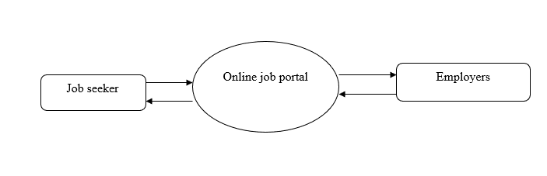

Figure 2. : Conceptual Framework

## CHAPTER CONCLUSION

This research will aim at creating a platform where job seekers can easily find available job opportunities that they can comfortably accomplish if hired for the positions. The job portal will provide a surface where anyone can find the job they qualify for easily and employers can find the right workers for their job effortlessly. The discussed systems have already implemented a majority of the tasks and created a baseline on which this research will be based.

# CHAPTER THREE: SYSTEM RESEARCH METHODOLOGY

## INTRODUCTION

The development methodology that will be used to develop the system will be discussed in this chapter. It will involve discussing why the methodology will be used, the methodology, and the steps involved in the methodology.

## DEVELOPMENT METHODOLOGY

System development methodologies are a means of improving the management and control of the software development process, structuring and simplifying the process, and standardizing the development process and the product by specifying activities to be done and techniques to be used. Agile system design methodology will be used for the system development.

The Agile methodology manages a project by breaking it up into several manageable phases. Agile methodology involves constant collaboration with stakeholders and continuous improvement at every stage of development. Once the work begins, the teams cycle through a process of planning, executing, and evaluating and Continuous collaboration, together as team members and project stakeholders. Agile methodology allows flexibility, adaptation to change, and a high level of customer input. In the agile SDLC development process, the customer can see the result of each stage and understand whether he/she is satisfied with the results or not.

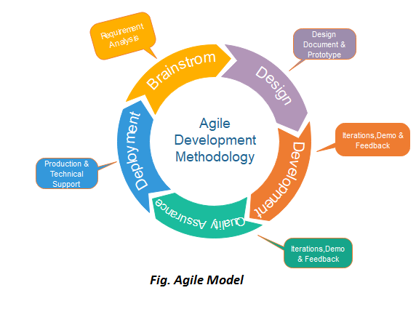

Figure 3.1 Agile methodology

The phases involved in the Agile Software Development Methodology are; Requirement gathering and analysis, Designing the requirements, Construction/ iteration, Deployment, Testing, and Feedback.

### Requirement gathering and analysis

This step involves the stakeholders examining the whole project to determine the required amount of time and resources needed to complete the development process. The owner also evaluates the risks and prioritizes the various functions based on their importance to the company. Technical information and economic feasibility is also assessed based on this information.

The researcher will determine how much time the project will take, the resources that will be used in the project and if they are available, and also the benefits of creating the project as a whole. The techniques that will be used in requirement gathering and analysis will be a document review of the existing study of the online jobs portal and the administering of online questionnaires to the target system users.

1. Designing the requirements

This involves working with the stakeholders to define requirements once the project had been defined. The software project owner meets with the software development team and walks them through the step's requirements. The team then examines the order in which functions will be introduced, as well as the necessary tools, such as the programming language, syntactic libraries, and basic frameworks. The Software development team prototypes the expected user interface at the same time.

The researcher will come up with the proposed system design that will be used to develop the system and the programming languages and technologies that also will be used in the system development. Design requirements will be achieved through developing prototypes of the proposed system using software design tools such as Lucid chart.

1. Construction/Iteration

The team then develops the designed product after the customer and the team have agreed on the plan to follow. The development work begins once the team has defined all the requirements. Both the designers and programmers then begin to work on the project. The product then get released in stages, with each sprint being aimed at improving the current version of the product. The product will go through several rounds of development until it is finished. The researcher will use programming languages to develop the proposed system. The programming languages that will be used for the front-end development will be HTML, CSS, and JavaScript. PHP programming language will be used for the back-end development and MYSQL will be used as the system database.

1. Deployment

The team creates a product for the user's work environment in deployment phase. The customers can use the software after it has been fully delivered. It then enters the maintenance phase as a result of this operation. The software development team gives ongoing support during maintenance time to ensure that the system works properly and any new defects are resolved.

The researcher will deploy the system to the target audience after the completion of development. The rolling deployment will be used to deploy the system. Rolling deployment involves updating a subset of the application instead of the full update of the system. The rolling deployment will be used as it offers flexibility in scaling up the new version before scaling down the old version.

1. Testing

To guarantee that the delivered project is completely functional and as designed, the quality assurance team conducts some tests on the system . The members of the Agile team test the system to ensure that it is bug-free; if any potential problems or defects are discovered, the developers address them as soon as possible. Users are also trained on how to use the developed system at this stage.

The researcher will carry out testing after the system has been developed on some intended users of the system to ensure that the system is as intended and that all the requirements of the system have been met. Functional testing will be used to test whether all functionalities in the system are catered for and that no critical functionality is missing.

1. Feedback

The final stage after releasing the product to the target audience is to get feedback on it. The team receives feedback on the product throughout this feedback step and can work through it. The Agile development cycle comes to an end at this point.

The researcher will get feedback on the system through a feedback form that will be available on the system's homepage.

## JUSTIFICATION OF METHODOLOGY

Agile methodologies empower the creation of the right product from scratch. Agile development methodology is great for software development because it helps analyze and improve products while they are going through the different phases of development, therefore, enabling the production of valuable products that are highly competitive.

Some principles exist to guide Agile methodologies which include:

Ensuring customer satisfaction: Agile methodologies help to satisfy the customer through early delivery and continuous delivery of valuable software as required by the customer.

Enhancing change: Even late in development, agile processes harnesses change for enhancing customer satisfaction and increasing their competitive advantage over other development methodologies.

Fast delivery of systems: Agile methodology tries to ensure that the software is delivered on time as soon as possible.

Promoting corporation: Throughout the duration of the project development, business people and developers must collaborate and share feedback regularly to ensure faster product improvements and delivery.

Providing support: Agile methodology aligns individuals to the overarching vision of the project and the company. It motivates the team working on a project and gives them the support and environment they need to thrive.

Champions face-to-face conversation: Through processes like a short daily scrum, important information is conveyed efficiently and effectively via a face-to-face conversation.

Ensuring that the software works as intended: It is only when software works, that the success of agile can truly be measured. That’s why agile has rigorous testing inbuilt into the process.

Promoting sustainable development: With agile methodology, the sponsors, developers, and users are all able to maintain a constant working pace for a long period.

Focusing on excellence: Agile methodology focuses on technical excellence and good design.

Simplifying the process: Agile methodology keeps the software development simple, and straight to the point.

Making the team self-dependent: With self-organizing teams, it’s easier to get the best architectures and designs from the teams. Teams are also more likely to be motivated as they have more autonomy and ownership over the project.

## DATA COLLECTION

Data collection is the gathering of useful information related to the topic of research. It is significant because it authenticates the issues related to the research gap.

The following data collection methods will be used to gather the data that will be used to develop the system requirements:

1. Document review

Document review is a way of collecting data by reviewing existing documents on the research topic. The researcher will review existing documentation of such job portal systems and any other job systems already reviewed. The researcher will identify the gaps and challenges the existing systems face and gather them. The information gathered will help create the proposed system by either getting a solution to the identified problems or proposing a better system.

1. Offering questionnaires

Questionnaires are survey instruments that are completed by the subjects. Questionnaires, like interviews, can contain short closed-ended questions (multiple choice) or broad open-ended questions. Questionnaires are used to collect data from a large group of subjects on a specific topic. Currently, many questionnaires are developed and administered online.

The researcher will use questionnaires to get insights into the requirements that the system will need. Mostly online questionnaires will be used as the job portal will also be an online system and most of the target audience will have access to online services.

1. Secondary Analysis of Data

Secondary analysis of data focuses on the re-use of quantitative data instead of textual data. For the secondary analysis, information from electronic databases or open-access research data depositories can be used, like standardized testing data, economic data, or consumer data. It is also possible to combine datasets from multiple sources.

Data from already conducted surveys on unemployment, possible measures to fix unemployment, and already-done research will be used to gather the project requirements.

## DATA ANALYSIS

Data analysis summarizes the collected data into useful information. It involves the interpretation of data gathered through the use of analytical and logical reasoning to determine patterns, relationships, or trends.

The following questions will be asked by the researcher to verify that all necessary data was captured.

* - Does the researcher have all data or missing data?
* - Does the research data have potential answers to the research questions?
* - Does the researcher have enough observations?

The researcher will therefore analyze the collected data for easy understanding by visualizing the data using charts and graphs and identifying correlations among the data

## CHAPTER CONCLUSION

The chapter focuses on analyzing the research methodology that will be used in the proposed system. The chapter highlights the workflow of how the system will be implemented and why the chosen system development methodology is the best for implementing the system.

# CHAPTER FOUR: SYSTEM DESIGN

## 4.1 INTRODUCTION

The system design is a critical component of the online job portal project as it outlines the architecture and functionality of the platform. In this chapter, the researcher described the various components of the system and their interactions with each other to meet the objectives of the project. The design will include a comprehensive description of the functional and non-functional requirements, architecture, and user interface design

## 4.2 REQUIREMENTS

The requirements of the online job portal are the foundation of the system design, as they define the functional and non-functional characteristics that the platform must meet. In this section, the researcher will describe the functional and non-functional requirements of the system in detail. The hardware and software, functional and non-functional requirements are as follows;

Software Requirements:

1. Operating System: Windows or Linux
2. Web Server: Apache, Nginx, or Microsoft IIS
3. Database Server: MySQL or PostgreSQL
4. Programming Language: PHP.
5. UI/UX Design: HTML5, CSS3, and JavaScript

Hardware Requirements:

1. Processor: Intel Core i5 or equivalent
2. RAM: 4 GB or higher
3. Storage: 250 GB or higher
4. Network: Broadband internet connection
5. Keyboard and Mouse

Functional Requirements:

* User authentication and verification: The system must provide secure authentication and verification of employers and job seekers.
* Job posting and application: Employers must be able to post job opportunities and job seekers must be able to apply for them.
* CV management: Job seekers must be able to upload and manage their CVs, showcasing their skills and qualifications.
* Search and filtering: Employers must be able to search for suitable job seekers based on specific criteria such as skills, experience, and location.
* Communication: The platform must provide a mechanism for employers and job seekers to communicate with each other.

Non-functional Requirements:

* Security: The system must be secure and protect sensitive information, such as personal data and job postings.
* Scalability: The platform must be scalable to accommodate a growing number of users and job postings.
* Performance: The system must be fast and responsive, with minimal delays or downtime.
* Usability: The user interface must be intuitive and user-friendly, allowing employers and job seekers to easily navigate the platform.
* Accessibility: The platform must be accessible to users with varying levels of technical proficiency and internet connectivity.

The requirements of the online job portal form the basis for the system design and development. By defining the functional and non-functional characteristics of the platform, the researcher will ensure that the system meets the needs and expectations of its users, delivering a seamless and efficient experience.

## 4.3 CONTEXT LEVEL DIAGRAM

The context level diagram is a high-level representation of the online job portal system, showing the relationship between the system and its environment. The context level diagram provides a comprehensive overview of the system's functionality and identifies the major components and interactions of the platform.

The context level diagram of the online job portal consists of the following components:

* Users: This component represents the employers and job seekers who use the platform.
* Online Job Portal System: This component represents the platform itself and its various functionalities, such as job posting, CV management, and communication.
* External Systems: This component represents external systems that the platform interacts with, such as databases and payment systems.

The relationships between these components are as follows:

* Users access the Online Job Portal System to post job opportunities or apply for job postings.
* The Online Job Portal System communicates with external systems to store and retrieve data, such as job postings and user profiles.

Query info

Request data

Database

Users

Respond with data

Respond

Figure 4.1 context level diagram

The context level diagram provides a high-level understanding of the online job portal system and its interactions with its environment. It forms the foundation for the detailed design of the platform, which will be covered in subsequent chapters.

In conclusion, the context level diagram provides a visual representation of the online job portal system, highlighting its key components and interactions. By identifying the major elements and relationships of the platform, we gain a better understanding of its functionality and purpose, helping to guide the development of the system.

## 4.4 INPUT DESIGN (USER INTERFACES)

The input design of a system is the process of defining how data will be collected and processed by the platform. In this chapter, we described the inputs of the online job portal system in detail, including the different designs for the input pages.

4.4.1 Registration page:

The registration page is a crucial component of the online job portal system. This page allows users to create a profile on the platform, either as an employer or a job seeker. The Purpose of the registration page is to gather essential information about the users of the online job portal system. This information is used to create a user profile and verify the identity of the users. Some features of the registration page include fields for entering personal information, such as name, email address, and password. The registration page is designed to be simple and user-friendly, allowing users to quickly and easily create a profile on the platform. The page includes clear instructions and error messages to guide users through the process and ensure that all necessary information is captured. The registration page is important for the success of the online job portal system, as it ensures that accurate information about users is captured and stored. This information is used to match job seekers with suitable job opportunities and employers with the right candidates.

|  |
| --- |
| Login  Online jobs portal    Repeat Password  Password  Register  Role (employer/job seeker)  Location  Phone No:  Email address  Full name |

Figure 4.2: Registration page

Overall, the registration page is an essential component of the online job portal system and plays a crucial role in its success. By providing a simple and user-friendly way for users to create a profile on the platform, the registration page helps to ensure the accuracy and efficiency of the system.

4.4.2 Login page

The login page is a key component of the online job portal system, as it allows users to access their profiles and interact with the platform. The login page is used to verify the identity of the users of the online job portal system. Users are required to enter their email address and password to access their profiles. The login page includes fields for entering the email address and password, as well as a button to submit the login information. The page also includes options for users to reset their password if they forget it and to create a new account if they are not already registered. The login page is designed to be simple and straightforward, allowing users to quickly and easily access their profiles. The page includes clear instructions and error messages to guide users through the process and ensure that they are able to access their profiles successfully. The login page is important for the security and efficiency of the online job portal system, as it ensures that only authorized users are able to access their profiles and interact with the platform.

|  |
| --- |
| Login  Forgot password  Password  Email |

Figure 4.3: Login form

Register

Online jobs portal

4.4.3 Job posting

The job posting page is a key component of the online job portal system, allowing employers to post job opportunities for job seekers to apply to. The job posting page is used to gather information about job opportunities from employers and make them available to job seekers on the platform. The page allows employers to enter details about the job, including the job title, location, salary, and required skills and qualifications. The job posting page includes fields for entering job information, as well as options for employers to upload supporting documents and files. The job posting page is designed to be simple and user-friendly, allowing employers to quickly and easily post job opportunities on the platform. The page includes clear instructions and error messages to guide employers through the process and ensure that all necessary information is captured.

Overall, the job posting page is a critical component of the online job portal system, enabling employers to reach a large pool of job seekers and find the right candidate for their job opportunities. By providing a simple and straightforward way for employers to post job opportunities, the job posting page helps to ensure the efficiency and effectiveness of the system.

|  |
| --- |
| Supporting documents  Add job posting  salary  Required skills  Job location  Job title  Profile  Online jobs portal |

Figure 4.4: Job posting

## 4.5 PROCESS DESIGN

The process design is a critical component of the online job portal system, as it outlines the steps involved in the key functions of the platform. The process design provides a detailed explanation of the processes involved in the system, including user registration, job posting, and employee application. The following are the steps involved in process design:

1. User Registration: The user registration process is the first step for users to access the online job portal system. Users are required to create an account and complete a profile, which includes their contact information, work experience, and education.
2. Job Posting: The job posting process is the second key function of the online job portal system. Employers are required to create a job posting, which includes details about the job opportunity such as the job title, location, salary, and required skills and qualifications.
3. Employee Application: The employee application process is the third key function of the online job portal system. Employees are able to view job postings posted by employers and apply to those they are interested in. The application process involves submitting a cover letter and resume, and providing additional information about the employee's qualifications and experience.
4. Hiring Process: The hiring process is the final step in the online job portal system. Employers are able to review the applications submitted by employees and choose the best candidate for the job based on their qualifications and experience. The hiring process includes communication between the employer and employee to negotiate salary and other terms of employment.

|  |
| --- |
| No  Goto joseeker homepage  yes  Goto employer homepage  employer  No  Create account  yes  Login  Has account  Load homepage |

Figure 4.5: process design flowchart

The process design is a critical component of the online job portal system, providing a clear and concise explanation of the steps involved in the key functions of the platform. By outlining the processes involved in user registration, job posting, employee application, and the hiring process, the process design helps to ensure the efficiency and effectiveness of the system.

## 4.6 DATABASE DESIGN

Database Design is an essential component of the online job portal project, as it provides the framework for storing and organizing all of the data that the system generates. The database design includes the definition of the data structures, relationships between tables, and the processes used to populate and manage the data.

The first step that was involved in designing the database was to define the data requirements. This included a clear understanding of the information that needs to be stored in the database, such as job postings, user profiles, and applications. Based on this information, the data structures were defined, including the tables, fields, and relationships between tables.

Next, the data management processes were defined. This included the processes for inserting, updating, and retrieving data from the database, as well as the processes for maintaining data integrity and security. These processes were defined using SQL, a standard language for managing relational databases.

Once the data structures and processes had been defined, the database can be implemented using a database management system (DBMS). The DBMS is responsible for managing the data, ensuring data integrity and security, and providing access to the data through APIs and other interfaces.

The following tables were designed and later used in implementing the online jobs portal;

* 1. User\_profiles table

| Column Name | Data Type | Constraints | Description |
| --- | --- | --- | --- |
| u\_id | INT(11) | NOT NULL, AUTO\_INCREMENT, PRIMARY KEY | Unique identifier for each user. |
| role\_id | INT(2) | NOT NULL, DEFAULT 2 | Identifier for user role. |
| u\_name | VARCHAR(25) | NOT NULL | User's full name. |
| u\_username | VARCHAR(25) | NOT NULL | User's unique username. |
| u\_email | VARCHAR(50) | NOT NULL | User's email address. |
| u\_phone | VARCHAR(15) | NOT NULL | User's phone number. |
| u\_county | VARCHAR(30) | NOT NULL | User's county or region of residence. |
| u\_address | VARCHAR(15) | NOT NULL | User's physical address. |
| u\_gender | VARCHAR(20) | NOT NULL | User's gender. |
| u\_m\_status | VARCHAR(20) | NOT NULL | User's marital status. |
| u\_dob | DATE | NOT NULL | User's date of birth. |
| u\_image | VARCHAR(255) | NOT NULL | Path to user's profile image. |
| u\_status | VARCHAR(10) | NOT NULL | User's account status. |
| u\_password | VARCHAR(255) | NOT NULL | User's password. |
| created\_at | TIMESTAMP | DEFAULT CURRENT\_TIMESTAMP | Timestamp indicating when the user record was created. |
| role\_id | FOREIGN KEY | REFERENCES roles(id) | Constraint linking the role\_id field to the id field in the roles table. Ensures data integrity. |

Table 4.1: Registration table design

* 1. Qualifications table

| Column Name | Data Type | Constraints | Description |
| --- | --- | --- | --- |
| q\_id | INT(11) | NOT NULL, AUTO\_INCREMENT, PRIMARY KEY | Unique identifier for each qualification. |
| u\_id | INT(11) | NOT NULL | Identifier linking the qualification to the user who obtained it. |
| q\_cv | TEXT | NOT NULL | Details of the qualification obtained by the user, such as course name, institution, and grade. |
| q\_resume | VARCHAR(255) | NOT NULL | Path to the user's qualification resume or certificate. |
| q\_date | TIMESTAMP | DEFAULT CURRENT\_TIMESTAMP | Timestamp indicating when the qualification record was created. |

Table 4.2 qualifications design

* 1. Job postings table

| Column Name | Data Type | Constraints | Description |
| --- | --- | --- | --- |
| jp\_id | INT(11) | NOT NULL, AUTO\_INCREMENT, PRIMARY KEY | Unique identifier for each job post. |
| u\_id | INT(11) | NOT NULL | Identifier linking the job post to the user who posted it. |
| jp\_title | VARCHAR(255) | NOT NULL | Title of the job post. |
| jp\_description | TEXT | NOT NULL | Description of the job post, including responsibilities and requirements. |
| jp\_type | VARCHAR(255) | NOT NULL | Type of job, such as full-time, part-time, contract, or internship. |
| jp\_category | VARCHAR(255) | NOT NULL | Category of job, such as sales, marketing, or engineering. |
| jp\_location | VARCHAR(255) | NOT NULL | Location of the job, such as city, state, or region. |
| jp\_salary | VARCHAR(255) | NOT NULL | Salary range for the job post. |
| jp\_status | VARCHAR(10) | NOT NULL, DEFAULT 'active' | Status of the job post, such as active, closed, or expired. |
| jp\_image | VARCHAR(255) | NOT NULL | Path to an image related to the job post, such as a company logo or job-related image. |
| jp\_date | TIMESTAMP | DEFAULT CURRENT\_TIMESTAMP | Timestamp indicating when the job post was created. |

Table 4.3 job posting design

## 4.7 OUTPUT DESIGN

The purpose of the output design is to provide a clear understanding of the type of data or information that will be produced by the system, and how it will be presented to the users. The output design should take into account the needs and expectations of the users, and should be designed in a manner that is easy to understand and use.

In the online jobs portal system, the outputs was grouped into two main categories: employer outputs and employee outputs. Employer outputs include job postings, job application status, and reports on hired employees. Employee outputs include a list of job postings, job application status, and reports on job applications. These outputs will be displayed on the user interface in a clear and organized manner, and will be accessible to the users through their profiles.

The output design also included security features to protect the privacy and confidentiality of the users’ information. The system was able to provide error messages and notifications in the event of any errors or problems with the data input. Overall, the output design of the online jobs portal system was should be user-friendly, efficient, and secure, providing the users with the information they need to effectively use the system.

The output of the online jobs portal will be a functional website that allows job seekers to search and apply for job postings, upload their resumes, and communicate with potential employers through a messaging system. It will also allow employers to post job listings, browse resumes, and communicate with job seekers. The website will be responsive and user-friendly, allowing for easy navigation and interaction with the platform. The output will be a complete and functioning system that meets all the requirements and specifications outlined in the project plan.

## 4.8 CHAPTER CONCLUSION

This chapter, System design of the online jobs portal project focuses on the system design and provides a detailed description of the requirements, process design, and database design of the system. In this chapter, the objectives, functional and non-functional requirements of the system were outlined, followed by a flowchart that provides a visual representation of the process design of the system. The database design was then described, including the tables and SQL columns that were defined to store the relevant information for job postings, user profiles, and job applications.

# CHAPTER FIVE: SYSTEM TESTING AND IMPLEMENTATION

## INTRODUCTION

Chapter 5 provides details on how the system was implemented and tested to ensure that it meets the project requirements and specifications. The implementation of the system involved the installation of necessary software and hardware components on the development and production servers. The testing process aimed to validate the system's functionality, usability, and performance, identifying any defects that needed to be corrected before the system could be deployed for public use. This chapter also outlines the various types of testing conducted, including unit testing, integration testing, system testing, and acceptance testing.

## UNIT TESTING

Unit testing is the process of testing individual units or components of software to ensure that they are functioning correctly. The online jobs portal system was developed using PHP, HTML, CSS, JS, and several JS libraries. Unit testing was performed to ensure that each component of the system was working as intended. The following components were tested:

1. Login system: The login system was tested to ensure that users could log in with valid credentials and that the system would reject invalid credentials.

| Test Case | Test Description | Expected Outcome | Actual Outcome | Pass/Fail |
| --- | --- | --- | --- | --- |
| TC001 | Test that user can login with correct credentials | User should be able to login successfully and be redirected to the dashboard page | User was able to login successfully and was redirected to the dashboard page | Pass |
| TC002 | Test that user cannot login with incorrect credentials | User should not be able to login and should be prompted with an error message | User was not able to login and was prompted with an error message | Pass |
| TC003 | Test that user cannot login with empty username or password fields | User should not be able to login and should be prompted with an error message | User was not able to login and was prompted with an error message | Pass |
| TC004 | Test that user is redirected to login page if they try to access a protected page without logging in | User should be redirected to the login page and prompted to login before being able to access the protected page | User was redirected to the login page and prompted to login before being able to access the protected page | Pass |
| TC005 | Test that user is logged out when they click the logout button | User should be logged out and redirected to the login page | User was logged out and redirected to the login page | Pass |

Table 5.1: login testing

1. Job posting system: The job posting system was tested to ensure that employers could post jobs, and job seekers could view them.

| Test Case ID | Description | Expected Result | Actual Result | Pass/Fail |
| --- | --- | --- | --- | --- |
| T1 | Attempt to post job without all required fields filled in | System should prompt user to fill in all required fields before allowing job posting | System successfully prompted user to fill in all required fields before allowing job posting | Pass |
| T2 | Attempt to post job with valid input | System should successfully post the job and display it on the job board | System successfully posted the job and displayed it on the job board | Pass |
| T3 | Attempt to edit job posting with valid input | System should successfully update the job posting with the new information | System successfully updated the job posting with the new information | Pass |
| T4 | Attempt to delete a job posting | System should prompt the user to confirm the deletion and then remove the job posting from the job board | System prompted the user to confirm the deletion and then removed the job posting from the job board | Pass |

Table 5.2: job posting testing

1. User registration system: The user registration system was tested to ensure that users could register with valid details and that the system would reject invalid details.

| Test Case ID | Test Case Description | Expected Result | Actual Result | Pass/Fail |
| --- | --- | --- | --- | --- |
| 1 | Testing with valid input values for all required fields | Registration should be successful and the user should be redirected to the login page with a success message displayed | Same as expected | Pass |
| 2 | Testing with a duplicate email address | Registration should fail and an error message should be displayed indicating that the email address is already in use | Same as expected | Pass |
| 3 | Testing with a password that does not meet the requirements | Registration should fail and an error message should be displayed indicating the password requirements | Same as expected | Pass |
| 4 | Testing with blank fields | Registration should fail and an error message should be displayed indicating the required fields | Same as expected | Pass |
| 5 | Testing with a valid input value for all fields except the email field | Registration should fail and an error message should be displayed indicating that the email is invalid | Same as expected | Pass |

Table 5.3: registration testing

1. Messaging system: The messaging system was tested to ensure that job seekers could send messages to employers about job postings.

|  |
| --- |
|  |
| Test Case ID | Test Scenario | Test Steps | Expected Results | Actual Results | Pass/Fail |
| MSG001 | User clicks on "Contact" button on a job posting | 1. Click on "Contact" button | 1. Messaging box pops up with fields for name, email, message. |  |  |
|  |  |  | 2. User's name and email are automatically filled in. |  |  |
|  |  |  | 3. User can type in their message and attach files. |  |  |
|  |  |  | 4. User clicks "Send" button to send message. |  |  |
|  |  |  |  |  |  |
| MSG002 | User fills in all required fields and sends a message | 1. Fill in all required fields | 1. Message is sent successfully. |  |  |
|  |  |  | 2. User is redirected to a confirmation page. |  |  |
|  |  |  |  |  |  |
| MSG003 | User does not fill in all required fields and sends message | 1. Leave one or more required fields blank | 1. Message is not sent. |  |  |
|  |  |  | 2. An error message appears indicating which fields are blank. |  |  |

Table 5.4: messaging system testing

1. CV upload system: The CV upload system was tested to ensure that job seekers could upload their CVs, and employers could view them.

| Test Case ID | Test Case Description | Test Data | Expected Result | Actual Result | Pass/Fail |
| --- | --- | --- | --- | --- | --- |
| CVT\_001 | Test upload of a valid CV | A valid CV file | Successful upload message is displayed | Successful upload message is displayed | Pass |
| CVT\_002 | Test upload of an invalid file type | An invalid file type | Error message is displayed, upload is unsuccessful | Error message is displayed, upload is unsuccessful | Pass |
| CVT\_003 | Test upload of a file exceeding the maximum size | A file exceeding the maximum size | Error message is displayed, upload is unsuccessful | Error message is displayed, upload is unsuccessful | Pass |
| CVT\_004 | Test deletion of an uploaded CV | An uploaded CV | Successful deletion message is displayed | Successful deletion message is displayed | Pass |
| CVT\_005 | Test update of an uploaded CV | An updated CV file | Successful update message is displayed | Successful update message is displayed | Pass |

Table 5.5: cv upload testing

Each of these components was tested thoroughly, and any issues that were found were fixed before moving on to the next stage of testing. Unit testing helped to ensure that each component of the system was functioning correctly, and that the system as a whole would work as intended.

## INTEGRATION TESTING

Integration testing is a type of testing that is performed to test the integration between different modules or components of the software system. The main goal of integration testing is to ensure that the different components of the software system work together as expected and produce the desired results.

In the online jobs portal project, integration testing was performed to ensure that the different modules of the system worked together as expected. The different modules of the system include the user registration system, login system, job posting system, CV upload system, and messaging system.

Integration testing involved testing the interactions between these modules to ensure that they worked together seamlessly. This was done by testing the flow of data and control between the different modules of the system. The testing is done in a controlled environment to ensure that any issues that arise during the testing process are easily identified and fixed.

The integration testing phase was important as it helped to ensure that the different modules of the system were integrated correctly and worked together as expected. This phase also helped to identify any issues or bugs that may have been missed during the unit testing phase.

## 5.4 SYSTEM TESTING

System testing is the process of testing the complete system as a whole, to ensure that it meets the requirements and specifications. It involves testing the integration of all modules and components that make up the system. The purpose of system testing is to verify that the system as a whole is functioning correctly and efficiently, and that all the modules and components are working together seamlessly.

The system was testing for its flow functionality starting from when the user starts using the system. In system testing all the modules were tested on how the would work together to deliver a seamless experience. This ensured that the system worked as intended and any issues that arose were fixed.

## DATABASE TESTING

## IMPLEMENTATION OF REQUIREMENTS

Implementation is the process of deploying the system in the production environment. It involved installing and configuring the system, and ensuring that it was ready for use by the end-users. The implementation process included the following steps:

1. Installation: This involved installing the system on the production environment, including the hardware and software components.
2. Configuration: This involved configuring the system to meet the requirements of the end-users, including setting up the database, user accounts, and other system settings.
3. Data Migration: This involved migrating the data from the development environment to the production environment, ensuring that the data is accurate and complete.
4. User Training: This involved providing training to the end-users on how to use the system, including any new features or functionality that might have been added.

## CODING TOOLS

During the development of the Online Jobs Portal, several coding tools were utilized to aid in the implementation of the project. These tools helped to ensure that the coding was efficient, effective, and maintainable. Some of the coding tools used during the implementation phase of the project included:

1. Sublime Text Editor: Sublime Text Editor is a powerful text editor that was used to write the PHP, HTML, CSS, and JavaScript code used in the development of the Online Jobs Portal. The editor has various features such as syntax highlighting, auto-completion, and a mini-map that make coding more efficient.
2. XAMPP Server: XAMPP is a free and open-source cross-platform web server solution that was used to host the Online Jobs Portal during development. It provides an easy way to create a local web server environment, which is useful for testing and debugging the application.
3. GitHub: GitHub is a web-based platform used for version control and collaboration on coding projects. It was used to host the Online Jobs Portal project files, enabling multiple developers to work on the same codebase simultaneously.
4. MySQL Workbench: MySQL Workbench is a visual tool used to design, develop, and manage MySQL databases. It was used to create the database schema and tables for the Online Jobs Portal.
5. PHPMailer: PHPMailer is a PHP library used to send email messages. It was used to send emails to job applicants and employers on the Online Jobs Portal.

These coding tools were crucial in ensuring the successful implementation of the Online Jobs Portal project. They helped to streamline the development process, making it more efficient and effective.

## SYSTEM HOMEPAGE

The system homepage is the first page users interact with when accessing the Online Jobs Portal. It serves as the entry point to all the functionalities provided by the system. Therefore, it was crucial to ensure that the homepage is tested and functioning as expected before the system was released for use.

To test the system homepage, we performed the following tests:

1. Navigation Test: This test checked if all the links on the homepage are functional and lead to the correct pages. It also verified that the navigation menu is responsive and easy to use.
2. Content Test: This test checked if the content on the homepage is accurate, up-to-date, and relevant to the users. It also ensured that the images and media files were loading correctly.
3. Compatibility Test: This test checked if the homepage is compatible with various devices, operating systems, and web browsers. It ensures that the homepage is responsive and accessible to all users.
4. Performance Test: This test checked if the homepage is loading fast and has a reasonable page load time.
5. Usability Test: This test checked if the homepage is easy to use, intuitive, and user-friendly. It ensured that the users can navigate the homepage without any difficulty and find the information they need.

By performing these tests, we ensured that the system homepage was functional, user-friendly, and meets the requirements of the users. It also helped to identify and fix any issues before the system was released for use.

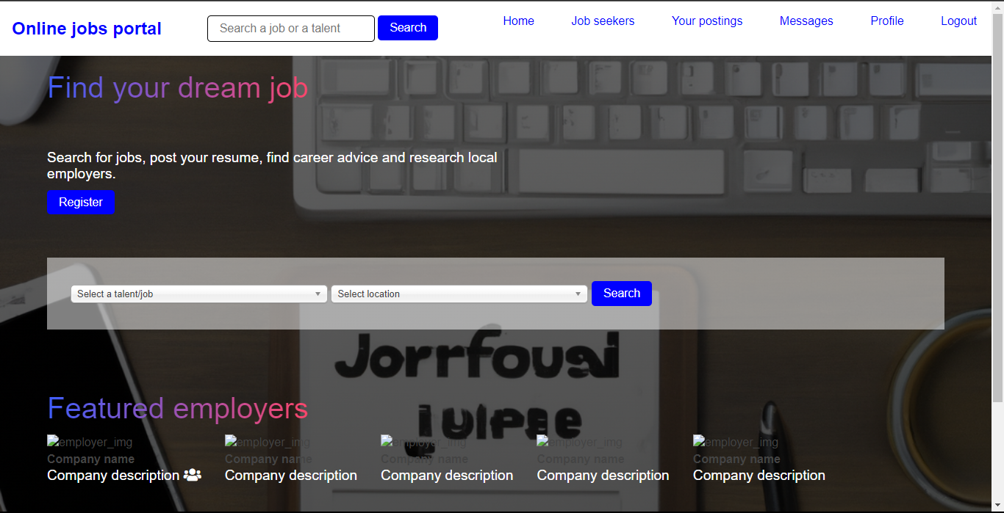

Figure 5. online jobs portal homepage

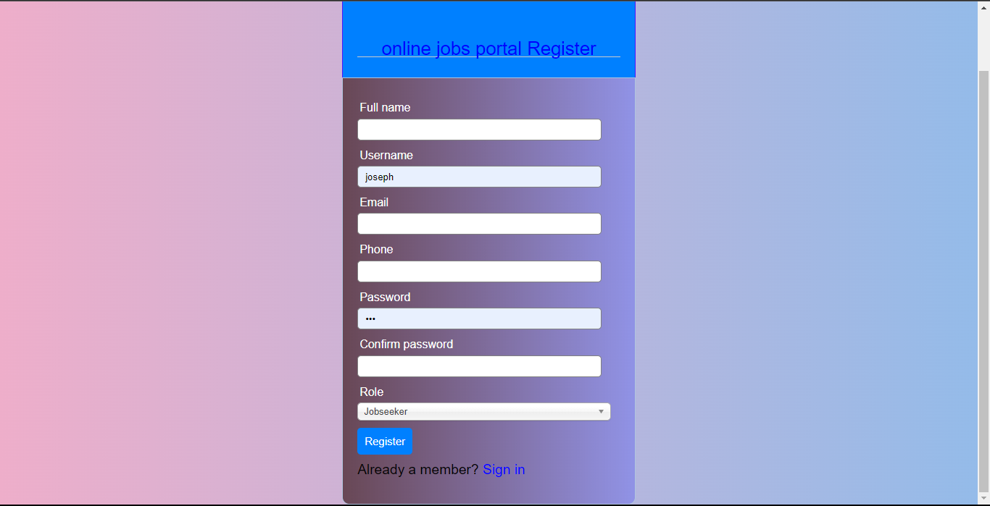

Figure 5. online jobs portal registration page

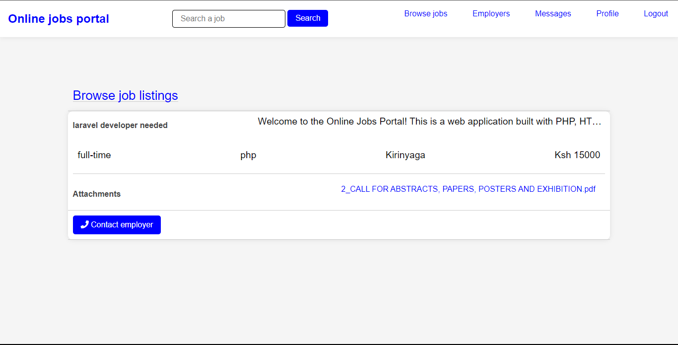

Figure 5. : online jobs portal browse jobs page

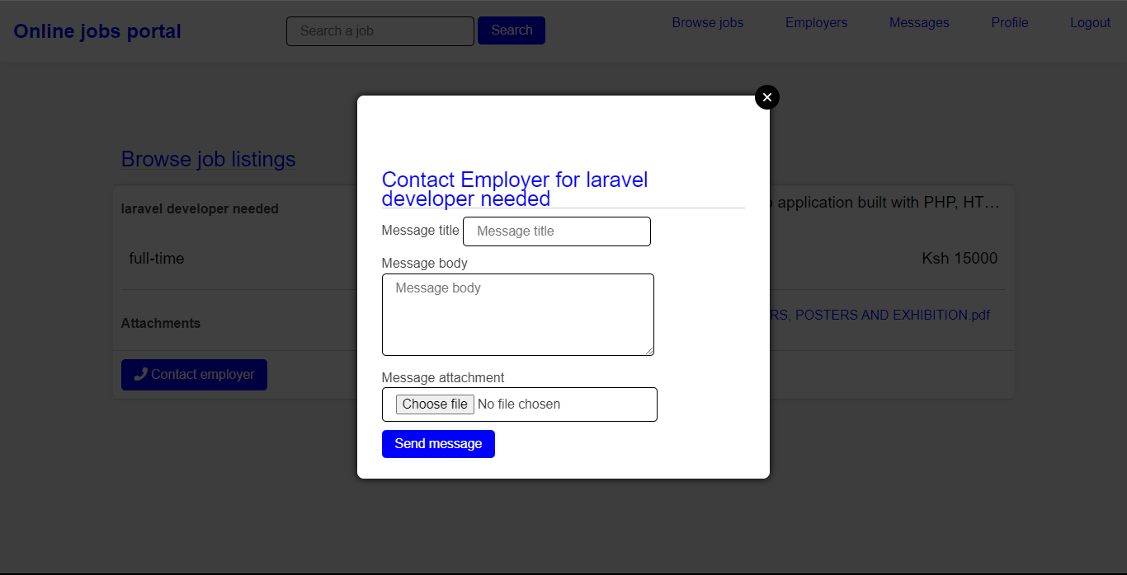

Figure 5. : online jobs portal contact employer page

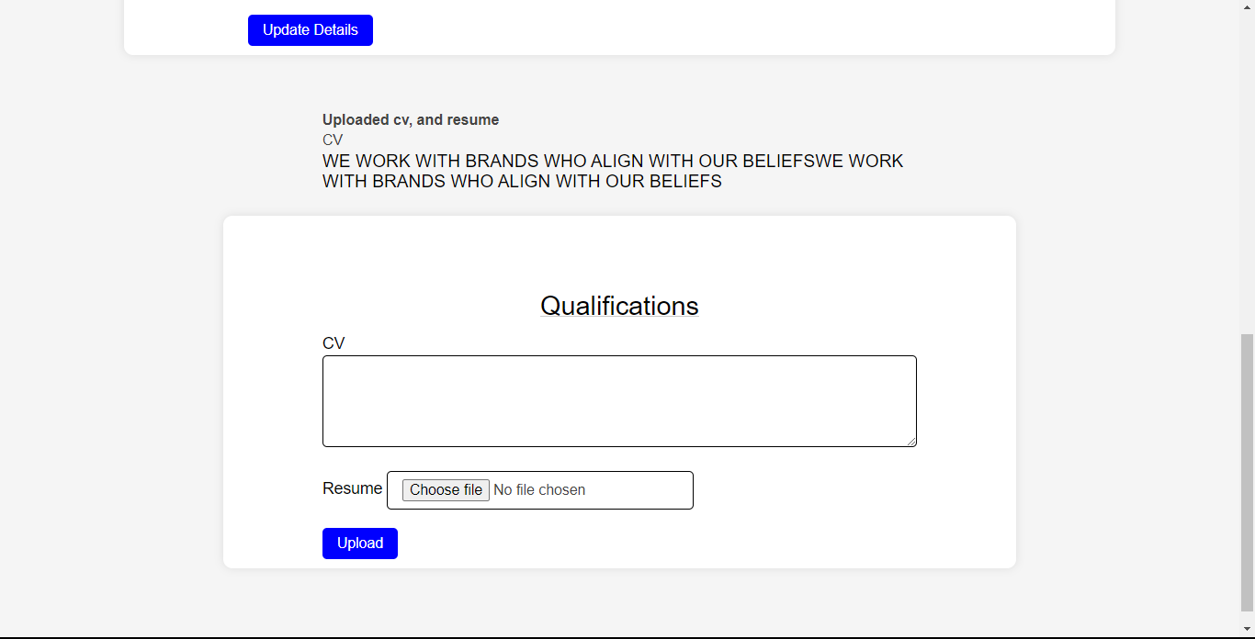

Figure 5. : online jobs portal upload qualifications page

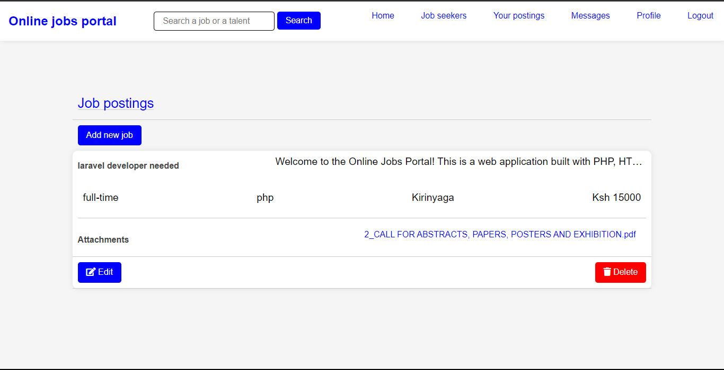

Figure 5. : online jobs portal add job listings page

## CHAPTER CONCLUSION

In this chapter, it focused the importance of testing in the software development life cycle and the various types of testing that were conducted on the Online Jobs Portal. This chapter started by discussing unit testing, which involves testing individual components of the system to ensure that they are working as expected, then moved on to integration testing, which involves testing how different components of the system work together. Finally, on system testing, which involves testing the system as a whole to ensure that it meets all the requirements.

This chapter also discussed the various coding tools that were used in the development of the Online Jobs Portal, including PHP, HTML, CSS, JavaScript, and various libraries such as SweetAlert, jQuery, Choosen, and WaitMe, then presented a detailed report on the testing of each system feature, including the login system, user registration system, CV upload system, job posting system, and messaging system.

# CHAPTER SIX: CONCLUSIONS AND RECCOMMENDATIONS

## 6.1 INTRODUCTION

## 6.2 CONCLUSION

## 6.3 RECCOMMENDATION

## 6.4 FUTURE WORK

# REFERENCES

community, S. d. (2019, January 04). *Reasons Why You Should Use Agile Methodologies For Your Next Software Development*. From Medium: https://medium.com/@SoftwareDevelopmentCommunity/7-reasons-why-you-should-use-agile-methodologies-for-your-next-software-development-4341257039c6

*Data collection methods*. (2019, September 27). From Jotform: https://www.jotform.com/data-collection-methods/#home\_section

Engineering, I. J. (2017, May 05). *A Review on Job Portal- A Web Application for Distributed Clients.* From ijarcce.com: https://ijarcce.com/upload/2017/may-17/IJARCCE%2019.pdf

*Importance of Data Collection*. (n.d.). From dissertationhelp: https://www.dissertationhelp.co.in/our-process/importance-of-data-collection/

Javapoint. (n.d.). *Agile Software Development Life Cycle (SDLC)*. From Javapoint: https://www.javatpoint.com/agile-sdlc

Pittet, S. (n.d.). *The different types of software testing*. From Atlassian: https://www.atlassian.com/continuous-delivery/software-testing/types-of-software-testing

Pretoria, U. o. (2022, 10 25). *Data analysis and report findings*. From Library: https://library.up.ac.za/c.php?g=485435&p=4425510#:~:text=Data%20analysis%20is%20the%20most,determine%20patterns%2C%20relationships%20or%20trends.

Sacolick, I. (2022, April 06). *What is agile methodology? Modern software development explained*. From Infoworld: https://www.infoworld.com/article/3237508/what-is-agile-methodology-modern-software-development-explained.html

Tee, M. (n.d.). *How to get client feedback into your dev process*. From techbeacon.com: https://techbeacon.com/app-dev-testing/how-get-client-feedback-your-dev-process

Wrike. (n.d.). *What Is Agile Methodology in Project Management*. From Wrike: https://www.wrike.com/project-management-guide/faq/what-is-agile-methodology-in-project-management/

# APPENDICES